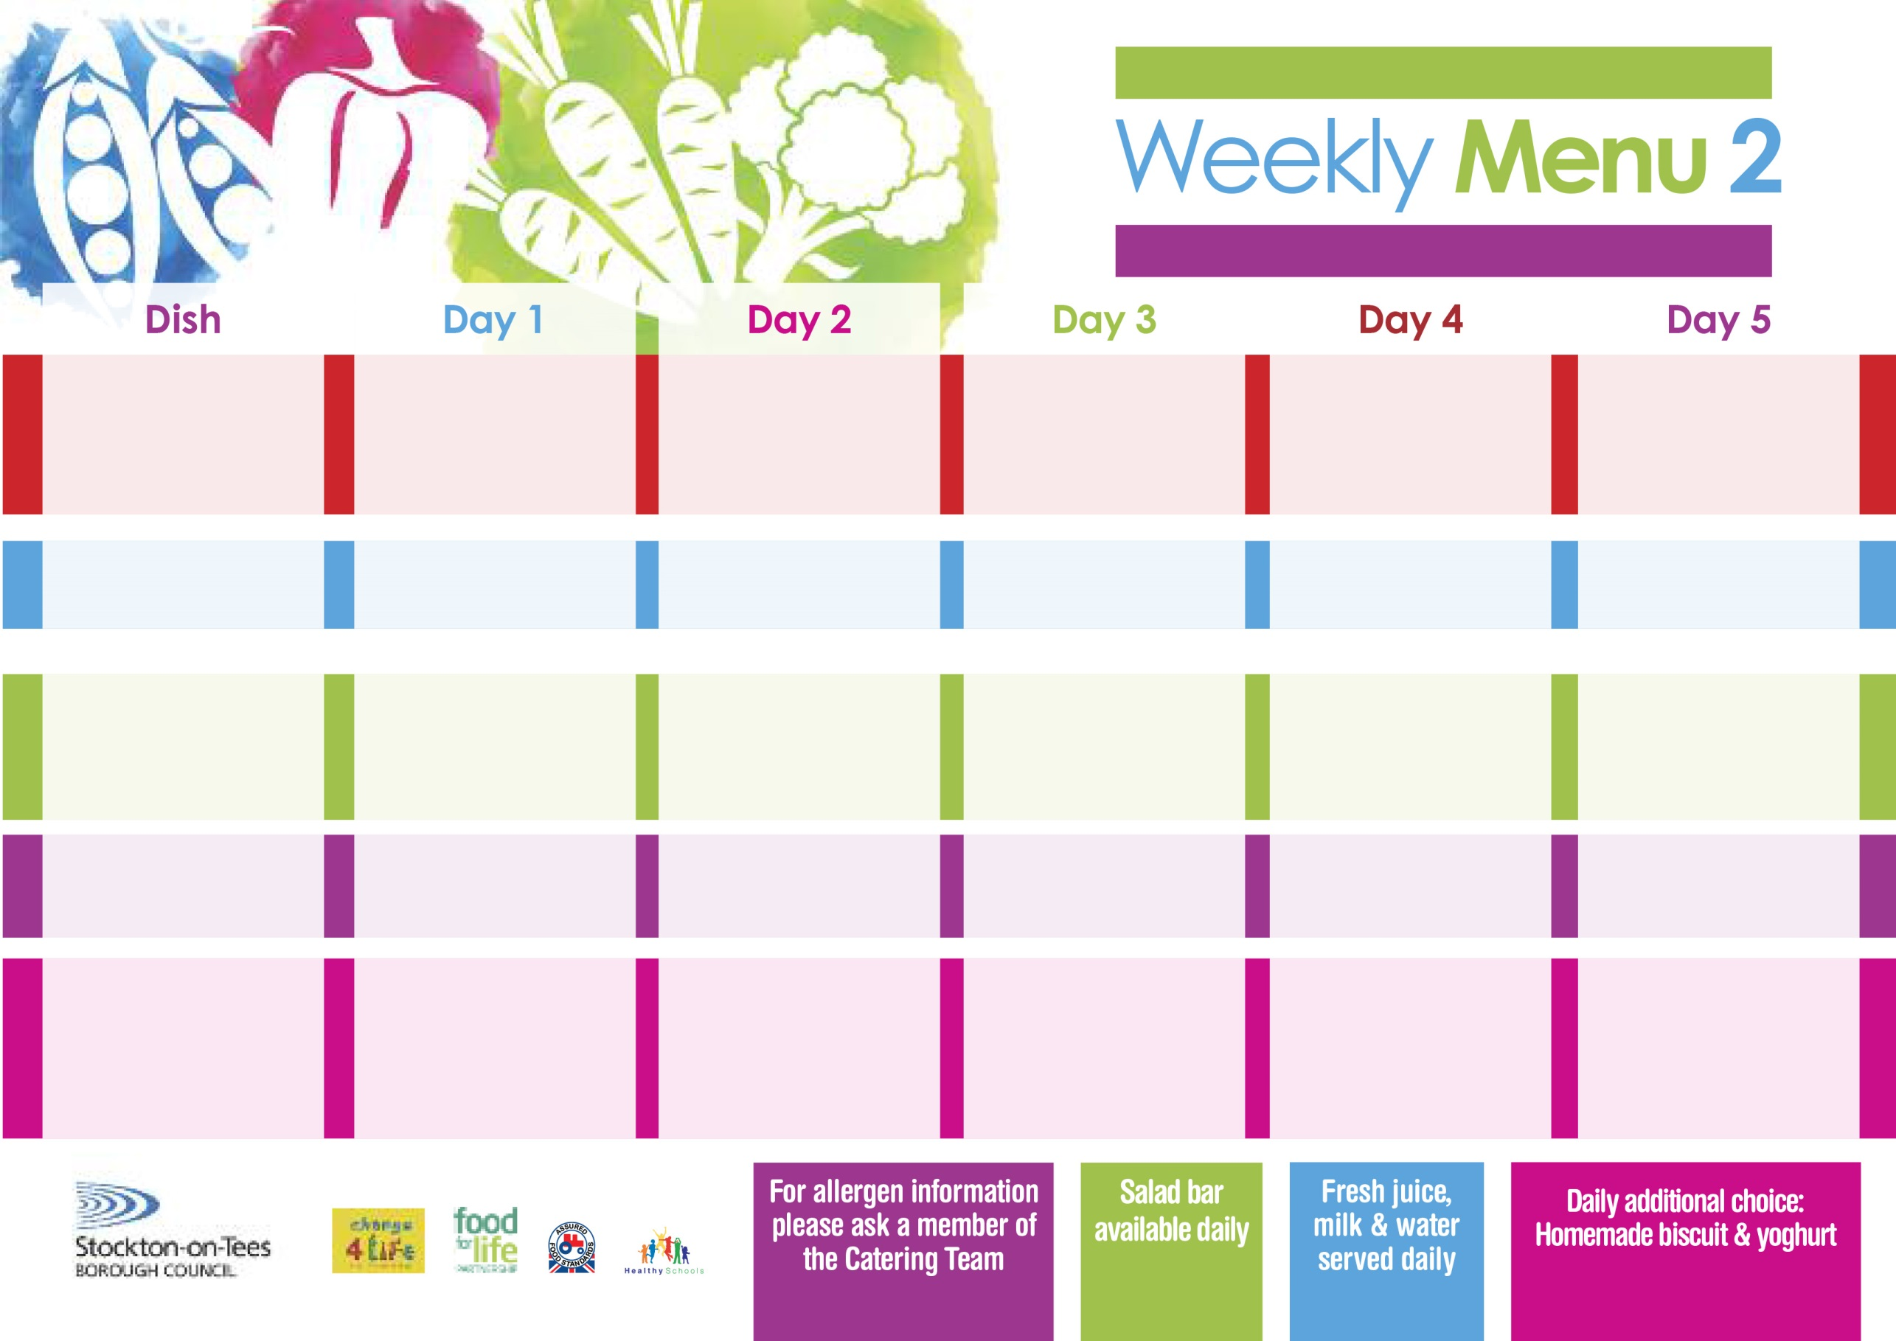

Name

Class

**9th & 30th September, 21st October, 18th November & 9th December, 2024 -**

**13th January & 3rd February, 2025**

**Homemade Pizza Whirl (V)**

**Baked Potato Wedges**

**Sweetcorn**

**Baked Beans**

**Penne Pasta in**

**Tomato Sauce (V)**

**Homemade Garlic Bread**

**Sweetcorn**

**Tuna Mayonnaise Sandwich**

**Baked Potato Wedges**

**Marble Sponge**

**with Custard Sauce**

**Angel Whirl**

**Homemade Biscuit**

**Fresh Fruit Bowl**

**Chicken Curry & Rice**

**Mixed Vegetables**

**Diced Quorn Curry**

**(V)**

**Jacket Potato filled with**

**Tuna, Cheese (V)**

**or Baked Beans (V)**

**Tossed Salad**

**Cheese Sandwich (V)**

**Baked Jacket Potatoes**

**Syrup Roly Poly**

**with Custard Sauce**

**Flapjack**

**Homemade Biscuit**

**Yoghurt**

**Beef Burger in a Bun**

**Oven Roasted Potatoes**

**Garden Peas**

**Spaghetti Hoops**

**Quorn Burger Bun**

**(V)**

**Cheese Omelette (V)**

**Oven Roasted Potatoes**

**Garden Peas**

**Spaghetti Hoops**

**Tuna & Cucumber Sandwich**

**Oven Roasted Potatoes**

**Homemade Apple Pie**

**with Custard Sauce**

**Jelly**

**Homemade Biscuit**

**Fresh Fruit Bowl**

**Fish Star**

**Oven Baked Chips**

**Garden Peas**

**Baked Beans**

**Homemade Quiche (V)**

**Oven Baked Chips**

**Garden Peas**

**Baked Beans**

**Egg Mayonnaise Sandwich**

**(V)**

**Oven Baked Chips**

**Vanilla Sponge**

**with Custard Sauce**

**Ice Cream Tub**

**Homemade Biscuit**

**Fresh Fruit Bowl**

**Minced Beef & Dumplings**

**Creamed Potatoes**

**Diced Carrots**

**Cauliflower**

**Minced Quorn & Dumplings**

**(V)**

**Baked Cheese Roll (V)**

**Baked Jacket Potatoes**

**Sweetcorn**

**Egg Mayonnaise Sandwich (V)**

**Baked Jacket Potatoes**

**Creamy Rice Pudding**

**with Jam Sauce**

**Decorated Iced Sponge**

**Homemade Biscuit**

**Yoghurt**

**Primary School Menu**

**Traditional**

**(Red)**

**Vegetarian**

**Choice**

**(Green)**

**Sandwich Selection**

(**Black**)

**Desserts**