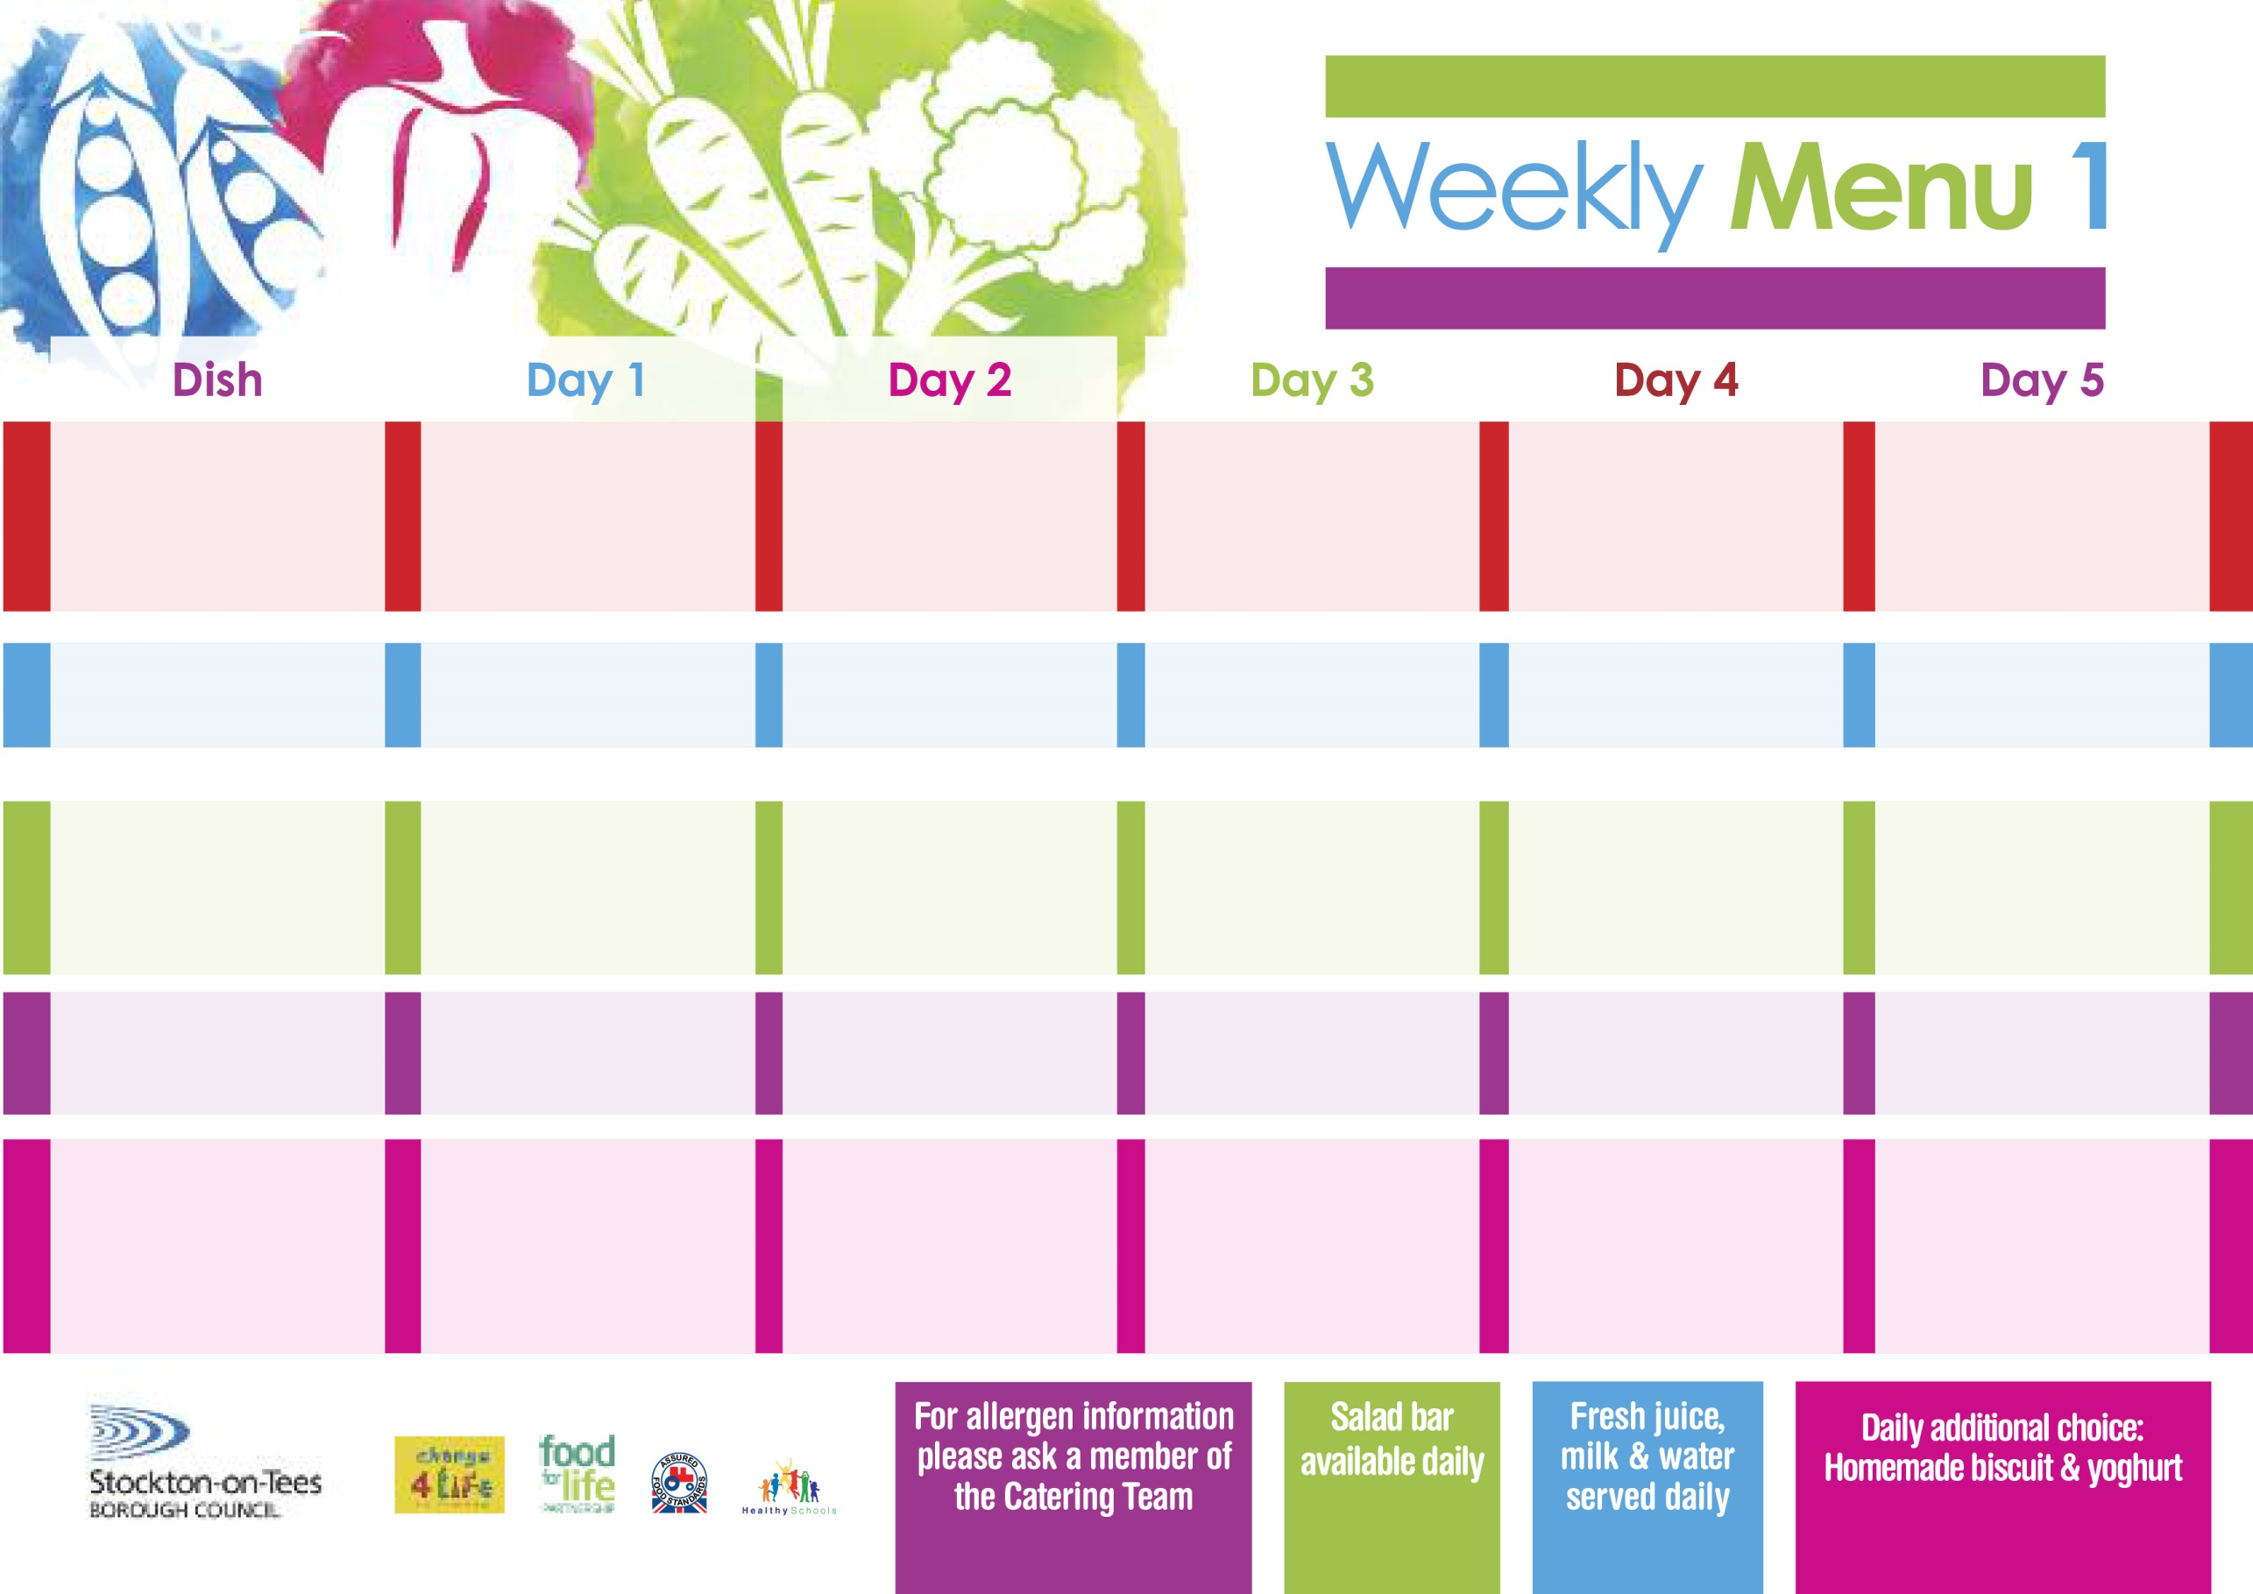

Name

Class

**2nd & 23rd September, 14th October, 11th November & 2nd December, 2024 -**

**6th & 27th January & 17th February, 2025**

**Fish Fillet Finger**

**Oven Baked Chips**

**Garden Peas**

**Baked Beans**

**Baked Quorn Sausage (V)**

**Oven Baked Chips**

**Garden Peas**

**Baked Beans**

**Cheese Sandwich (V)**

**Oven Baked Chips**

**Creamy Rice Pudding**

**with Jam Sauce**

**Ice Cream**

**Homemade Biscuit**

**Fresh Fruit Bowl**

**Minced Beef Pie**

**Creamed Potatoes**

**Diced Carrots**

**Broccoli**

**Minced Quorn Pie (V)**

**Quorn Dippers (V)**

**Baked Jacket Potatoes**

**Spaghetti Hoops**

**Tuna & Cucumber Sandwich**

**Baked Jacket Potatoes**

**Jam Sponge**

**with Custard Sauce**

**Raspberry Bun**

**Homemade Biscuit**

**Yoghurt**

**Homemade Pizza (V)**

**Oven Roasted Potatoes**

**Baked Beans**

**Jacket Potato filled with Tuna, Cheese (V)**

**or Baked Beans (V)**

**Tossed Salad**

**Egg Mayonnaise Sandwich**

**(V)**

**Oven Roasted Potatoes**

**Chocolate Crunch**

**with Custard Sauce**

**Jelly**

**Homemade Biscuit**

**Fresh Fruit Bowl**

**Spaghetti Bolognaise**

**Homemade Garlic Bread**

**Mixed Vegetables**

**Quorn Bolognaise (V)**

**Baked Cheese Roll (V)**

**Baked Potato Wedges**

**Spaghetti Hoops**

**Tuna Mayonnaise Sandwich**

**Baked Potato Wedges**

**Feathered Sponge**

**with Custard Sauce**

**Crispy Cake**

**Homemade Biscuit**

**Yoghurt**

**Primary School Menu**

**+**

**Baked Sausages in Gravy**

**Baby Boiled Potatoes**

**Green Beans**

**Sweetcorn**

**Baked Quorn Sausages in Gravy (V)**

**Homemade Quiche (V)**

**Baby Boiled Potatoes**

**Sweetcorn**

**Cheese Sandwich (V)**

**Baby Boiled Potatoes**

**Apple Crumble**

**with Custard Sauce**

**Chocolate Muffin**

**Homemade Biscuit**

**Fresh Fruit Bowl**

**Traditional**

**(Red)**

**Vegetarian**

**(Green)**

**Sandwich Selection**

(**Black**)

**Desserts**