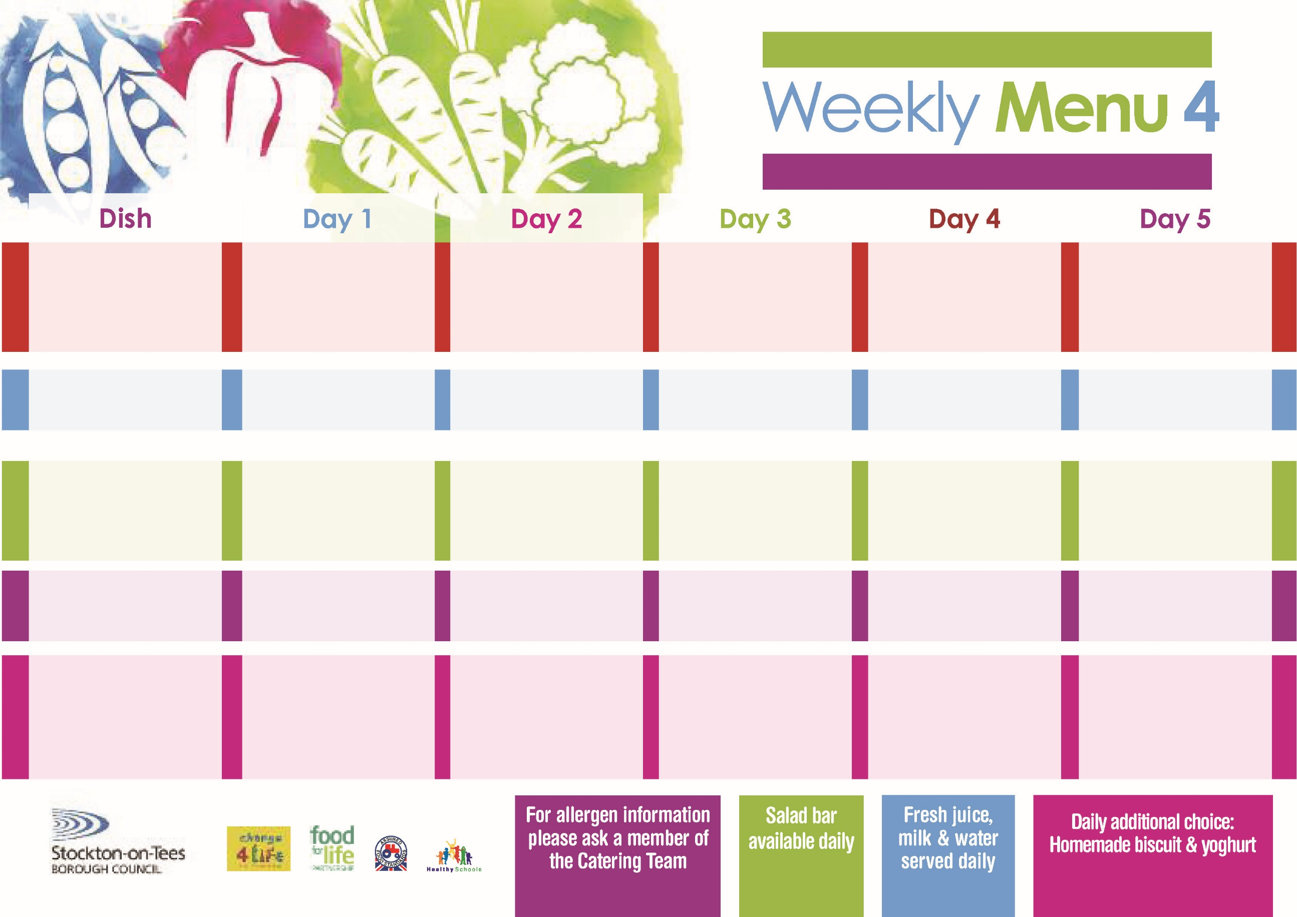

Name

Class

**6th May, 10th June & 8th July, 2024**

**Harry Ramsden Fish Fillet**

**Oven Baked Chips**

**Garden Peas**

**Baked Beans**

**Mini Cheese**

**& Onion Slice (V)**

**Oven Baked Chips**

**Garden Peas**

**Baked Beans**

**Egg Mayonnaise Sandwich**

**(V)**

**Oven Baked Chips**

**Syrup Sponge**

**with Custard Sauce**

**Cold Bar**

**Fresh Fruit Bowl**

**Lasagne**

**Homemade Garlic Bread**

**Tossed Salad**

**Coleslaw**

**Fish Cake**

**Baked Jacket Potatoes**

**Sweetcorn**

**Ham Sandwich**

**Baked Jacket Potatoes**

**Orange Sponge**

**with Custard Sauce**

**Cold Bar**

**Fresh Fruit Salad**

**Cheese & Tomato Pizza (V)**

**Oven Roasted Potatoes**

**Baked Beans**

**Sweetcorn**

**Jacket Potato filled with**

**Tuna, Cheese (V)**

**or Baked Beans (V)**

**Egg Mayonnaise Sandwich** **(V)**

**Oven Roasted Potatoes**

**Creamy Rice Pudding**

**with Jam Sauce**

**Cold Bar**

**Fresh Fruit Bowl**

**Chicken Curry**

**served with Rice**

**Mixed Vegetables**

**Quorn Meatballs**

**with Pasta in Tomato Sauce**

**(V)**

**Pork & Carrot Meatballs**

**with Pasta in Tomato Sauce**

**Mixed Vegetables**

**Cheese Sandwich (V)**

**Baked Jacket Potatoes**

**Cornflake Tart**

**with Custard Sauce**

**Cold Bar**

**Fresh Fruit Salad**

**Mince & Dumplings**

**Creamed Potatoes**

**Diced Carrots**

**Broccoli**

**Quorn Mince & Dumplings**

**(V)**

**Homemade Quiche (V)**

**Baked Jacket Potatoes**

**Diced Carrots**

**Broccoli**

**Tuna Sandwich**

**Baked Jacket Potatoes**

**Eve’s Pudding**

**with Custard Sauce**

**Cold Bar**

**Fresh Fruit Bowl**

**Red Choice**

**Blue Choice**

**Green Choice**

**Cold Selection**

**Desserts**

**Wristband Primary School Menu**