**Geography Monitoring Year 1** Summer Term

**Can you recall any key vocabulary for this topic?**

* Landmarks
* Elizabeth’s Tower – which is Big Ben
* London Eye
* Tower Bridge
* Buckingham Palace
* City – which is where you have lots of skyscrapers, people, museums and parks.
* Monarch – which is a King or Queen

Bright Lights, Big City

**What did you enjoy about the topic?**

I enjoyed learning about all the different landmarks. My favourite was Elizabeth’s Tower because I didn’t know it was called that. Did you know that when you lay all the pieces of The Shard down, it is the size of eight football pitches?

**Pupil Voice**

**What is Geography? What does it mean to be a geographer?**

Geography is when we learn about countries. It’s when people go all over the world and we learn about different places.

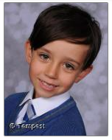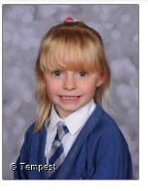

**What does Geography teach us about caring for our environment?**

It teaches us not to drop litter or rubbish on the floor because it could blow into the sea and animals could die. You also have to make sure you recycle and try to walk or use your bicycle to get to school, instead of going in the car.

